[Test Plan] BelajarBareng Website v1.0

Document Status | DRAFT
Test Plan Creator | Muhamad Rizq Rihaz
Test Plan Reviewer | - Reyhan  - Tyo  - Rama

Introduction

Overview Feature to be tested
This test plan is designed to ensure that the Login and Add User features on the belajar-bareng.onrender.com website function properly according to user needs and are free from annoying errors.

Goals and Objective
The purpose of this testing is to evaluate the functionality of the Login and Add User features on the belajar-bareng.onrender.com website. This testing is conducted using manual testing methods to ensure that each feature operates in accordance with the specified requirements and to identify any potential functional defects, are us follow:

- Testing the Login page features aims to ensure users do not experience problems when performing the login process. The test scenarios include the use of valid and invalid credentials, stable connection and unstable connection.
- The Add User page feature test aims to ensure admins can correctly add user data through the provided form. Testing is conducted to verify the validation of input such as username and age, and to ensure the data is properly saved in the system.

Test Item
List of test items (feature / product)

No | Feature | Test Item
#1 | Login | - Login with valid credentials  - Login with invalid credentials  - Login without input
#2 | Add User | - Add user with valid data  - Add user with invalid data  - Add user without input  - Add user with boundary age values  - Add user with duplicate username  - Add user with invalid input format

In Scope Testing
List of in feature to be tested

No | Feature | Requirement / Design specifications
#1 | Login | 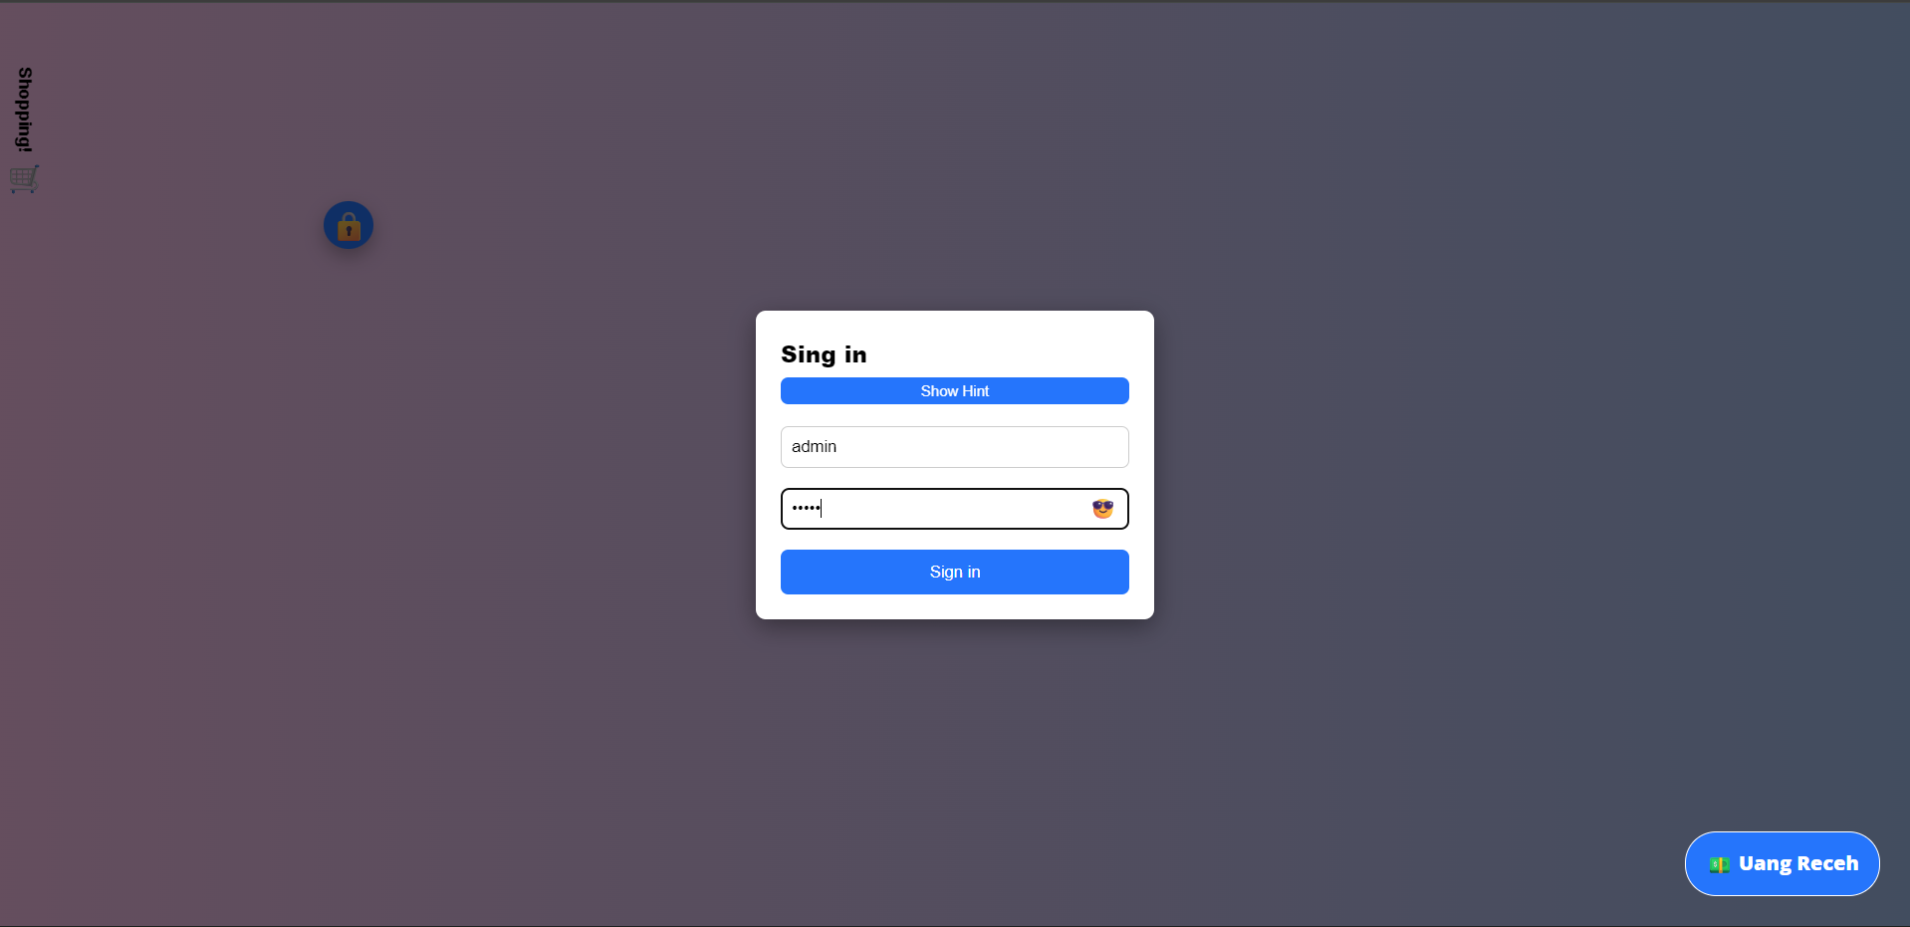
#2 | Add User | 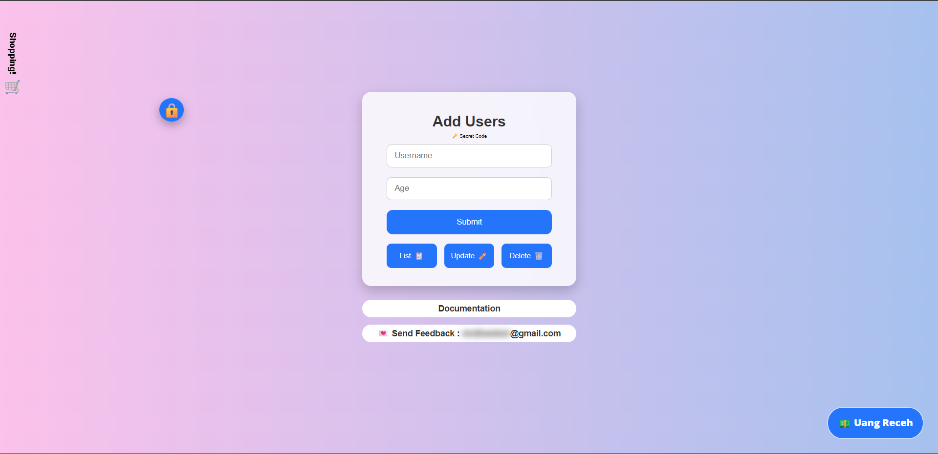

Out of Scope Testing
List the features of the software / product which will not be tested.

No | Feature | Reasons
#1 | Update User | Testing does not include user data update features at this phase
#2 | Delete User | Testing does not include the user data deletion feature at this stage
#3 | Checkout | The checkout feature is outside the defined testing focus

Testing Approach
The testing process was conducted using the Exploratory Testing method, where the tester had no prior knowledge of the belajar-bareng.onrender.com website development process. The tester explored the application to understand the system flow and identify potential errors. This approach was used to ensure that the tested features met user needs and were usable without issues.

Test Environment
Information about testing environment that will be used during testing phase e.g URL, and version of App
- Website: https://belajar-bareng.onrender.com
- Device: Laptop
- Env: Production
- Browser: Edge, Chrome, Firefox
- OS: Windows 11

Test Deliverables
- Test Plan (this document itself): [https://docs.google.com/document/d/10188_T4VW5M6c7TsNIv5KLZ2iNa9Bg7gXnB_aGxgjDs/edit?usp=sharing]
- Test Case: [https://docs.google.com/spreadsheets/d/1BuiM3qeNiPVtvWiR5uUqpuria6MTmQA30AW4UKFT3vk/edit?usp=sharing]
- Defect Report: [https://docs.google.com/spreadsheets/d/1BuiM3qeNiPVtvWiR5uUqpuria6MTmQA30AW4UKFT3vk/edit?usp=sharing]
- Test Report:
https://docs.google.com/document/d/10Vq6flBu2LF-5R7FarPPLB5z0-b4s6MD3oqJG6hbo0I/edit?usp=sharing

Testing Timeline

No | Task | Estimation Time |  | Actual Time
 |  | Start Date | Finish Date | Start Date | Finish Date
#1 | Develop Test Planning | 31 Mar 2026 | 1 Apr 2026 | 31 Mar 2026 | 1 Apr 2026
#2 | Develop Test Case | 2 Apr 2026 | 6 Apr 2026 | 2 Apr 2026 | 6 Apr 2026
#3 | Test Case Review | 7 Apr 2026 | 7 Apr 2026 | 7 Apr 2026 | 8 Apr 2026
#4 | Execute Test | 8 Apr 2026 | 13 Apr 2026 | 9 Apr 2026 | 14 Apr 2026
#5 | Retest Bug | 14 Apr 2024 | 16 Apr 2026 | 15 Apr 2026 | 17 Apr 2026

References
List of related documents e.g PRD, Figma design, API Contract, Copy document etc

API Contact: [https://belajar-bareng.onrender.com/documentation],
Website: https://belajar-bareng.onrender.com

